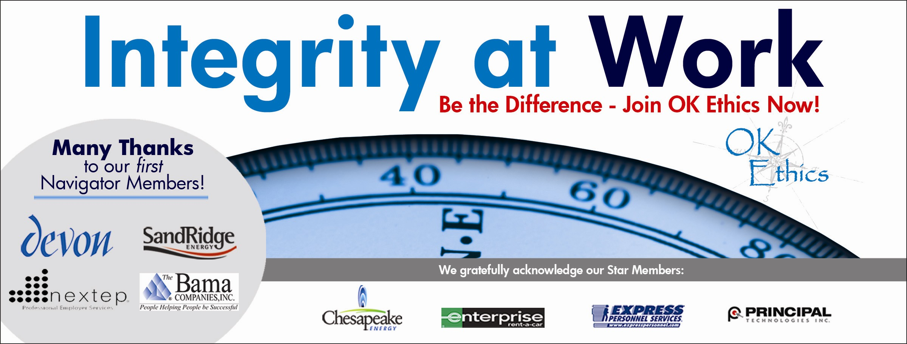

Oklahoma Business Ethics Consortium
Tulsa Chapter

June 26, 2008 – 11:30 a.m. to 1 p.m.

- Welcome and special recognition (11:50 -11:55) Nick Minden

Special thanks to OkEthics members John Stancavage, Michael Oonk, Carol Swarthout, Lynn Flinn and Lori Rowan for their help with this meeting.

II. Guiding Principle (11:55 – noon) Lynn Flinn

The Oklahoma Business Ethics Consortium’s activities are conducted under a set of guiding principles.

III. Introduction of speaker (Noon) Julian Joy

IV. Speaker Clifton Taulbert: “Inside Community: The Dynamics of Behavior”

Mr. Taulbert is one of America's thought-leaders on the "Power of Community" and views community in the workplace as a powerful leadership asset. He was chosen by CNN at the turn of the millennium to represent one of the voices of 'Community.' Mr. Taulbert is a Pulitzer nominated author and the President and Founder of the Building Community Institute. He is the author of the internationally acclaimed book, Eight Habits of the Heart, a book that provides the framework on which to build, maintain and sustain a powerful, effective and caring Community.

V. Membership update (12:50 – 12:55) Whitney Mathews

VI. Upcoming Events & Closing remarks (12:55 – 1:00) Nick Minden

Oklahoma City Chapter: July 9th - Kevin Ogle, News Channel 4 Anchor

Tulsa Chapter: July 24th – Panel Discussion featuring leading Oklahoma Manufacturing firms

NOTE: Members of the Oklahoma Business Ethics Consortium frequently share information concerning various issues and developments that may have legal implications. The discussions, commentary, and handouts at Consortium meetings or presentations to other organizations are for general informational purposes only. They cover only some aspects of the subject topic, and do not constitute a complete legal analysis of the topic or how it might apply to any particular set of facts. Before taking any action based on information presented by a Consortium member, participants are encouraged to consult a qualified attorney. The observations and comments of presenters at Consortium meetings and networking are the views and opinions of the presenter and do not constitute the opinion or policies of the Consortium or any of its members. Please note that speakers are advised in advance of OkEthics policy against politicking, preaching, self-promotion and profanity.
OkEthics

We always are seeking new members.

Join today – You can make a difference!

Corporate Level
NAVIGATOR – $7,500 Includes 16 memberships; prepaid for all OkEthics events – including annual Compass Award

STAR – $5,000 Includes 8 memberships; prepaid for all OkEthics events – including annual Compass Award

HORIZON – $2,500 Includes 8 prepaid meals

LEADING – $1,200 Includes 2 prepaid meals

FRONTIER – $350 Includes 8 memberships; no meals

Individual Level

Trailblazer = $500 (Includes 1 prepaid meal)

Scout = $75 (Individual membership, no meals)

For more information on membership, go to www.okethics.org

